**Task 1:**

Sending mail to sice-networks-l@list.indiana.edu

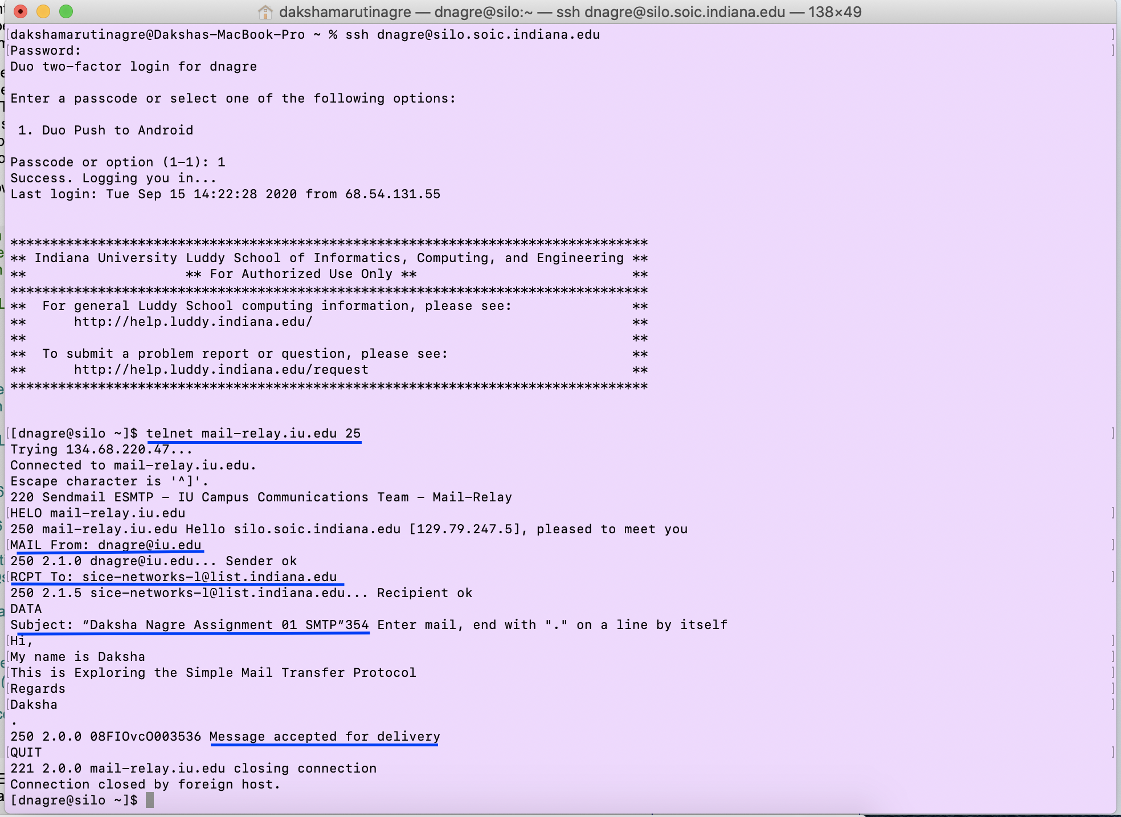

**Sending to the non IU email address.**

We cannot send email to non IU email address. The error we get is Relaying denied. Proper authentication is needed. This means it is failing at the handshake stage.

So, I think the mail relay server of IU is configured to send mails to IU address only.

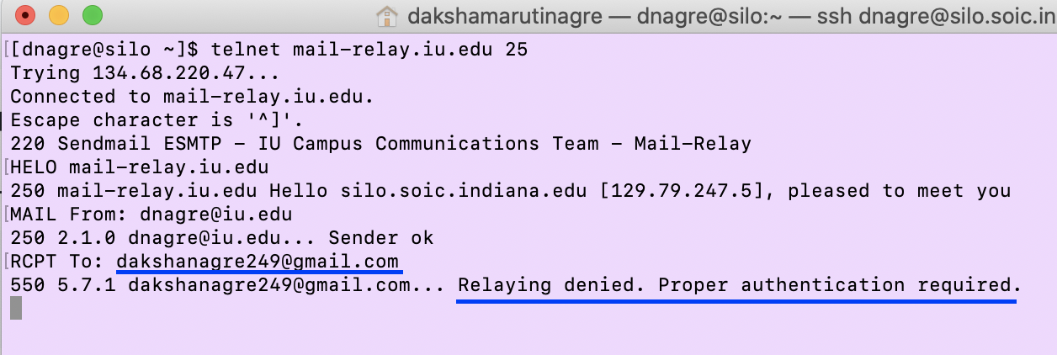

Sending email from fake email address

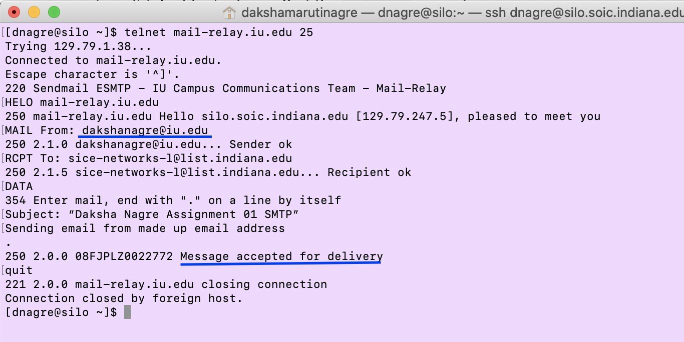

I can send email from a fake email address because SILO is open mail relay server i.e. open SMTP (Simple Mail Transfer Protocol) relay server.

Since the receiving server which is a legitimate server, both client and server can have handshake. Therefore, the receiving mail server can receive the data.

**Task 2:**

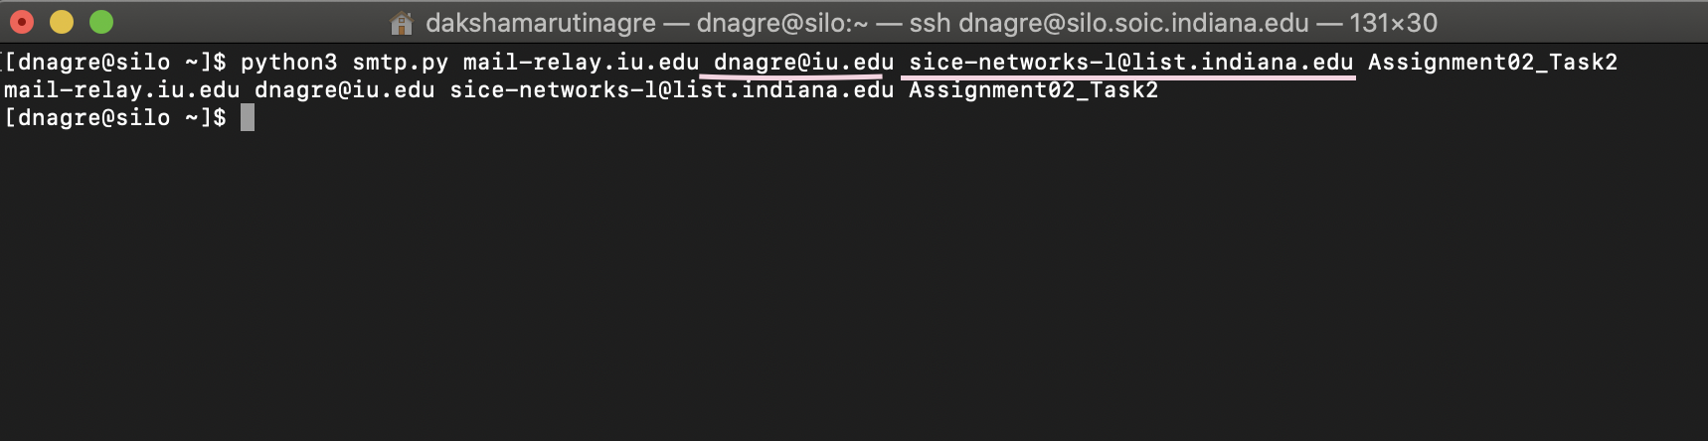

**Task 3:**

